14.24: a)
b)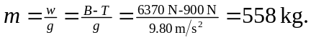
c) (See Exercise 14.23.) If the submerged volume is 